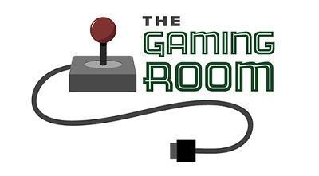

Draw It or Lose It

CS 230 Project Software Design Template
Version 2.0

Table of Contents

CS 230 Project Software Design Template 1
Table of Contents 2
Document Revision History 2
Executive Summary 3
Requirements 3
Design Constraints 3
System Architecture View 3
Domain Model 3
Evaluation 4
Recommendations 5

Document Revision History

Version | Date | Author | Comments
1.0 | 09/21/2026 | Joseph Thimote | Completed Executive Summary, Requirements, Design Constraints, and Domain Model
2.0 | 10/08/2026 | Joseph Thimote | Completed Evaluation & Evaluation Implications
3.0 | 10/16/2026 | Joseph Thimote | Completed Recommendations

Executive Summary

The Gaming Room wishes to gain more players and build up its user base by making the game Draw It or Lose It available to more platforms beyond Android. It wishes to port the game to the web. We propose an architectural design where the Game Service remains centralized to manage game and player data and client components remain in the browser. With this design, players can access the game from any platform. The Game Service should be designed to manage game data in a manner that implements the game rules to manage and handle shared game data. Game Service implementation should consider network latency, security, and other non-functional requirements.

Requirements

The Game Service should be designed and developed to support a game with multiple teams and players, unique and customizable game names, and unique identifiers. Game and Team names should be unique across all games. The Game Service should manage data for only a single game. The Game Service should be designed to support a game with four rounds, each with a time limit, and provide game clues to the players.

Design Constraints

Porting Draw It or Lose It to a web application presents a set of constraints. First, clients must be able to use the application from any platform. The user interface will therefore need to be browser-based, and the application logic will be server-based. The server will be responsible for defining and updating the game state. This may require the use of transactions. Simultaneous connections from various players may result in confusion as to which client owns what data. The server will also be responsible for defining time and coordinating activities. This constraint may require the server to implement a guess to verify scheme. Names entered by users must be validated to ensure uniqueness. Names may include game names and team names. Every participant, game and team must be assigned a unique identification number. This must be ensured at the time of creation. These constraints apply to a wide variety of services including, but not limited to, game and team creation, player management and game administration. Some of the constraints may also apply to the non-tech services offered by the business, services offered by partnering organizations, Some of the constraints, when applied to the service offerings, will require reliance on the public web.

System Architecture View

Please note: There is nothing required here for these projects, but this section serves as a reminder that describing the system and subsystem architecture present in the application, including physical components or tiers, may be required for other projects. A logical topology of the communication and storage aspects is also necessary to understand the overall architecture and should be provided.

Domain Model

The domain model uses the abstract Entity base class to define the name attributes shared by Game, Team, and Player. These subclasses inherit the shared state and accessor methods, which demonstrates inheritance and reusability. A Game manages one or more Team objects, and each Team manages multiple Player objects. These are one to many relationships; one game can contain many teams, and one team can contain many players.
GameService uses the Singleton pattern to manage games. The private constructor of GameService limits GameService object creation by clients. Access to the single GameService object is provided by the static method getInstance(). With this design all game information is managed by a single source and game ids are managed accordingly. The Iterator pattern is implemented to search for an entity by name or id. This implementation supports the game/team naming constraint by returning an already created entity instead of creating a new one. Encapsulation is implemented by declaring the fields as private and providing users of the class only the methods to invoke the operations on the entity.

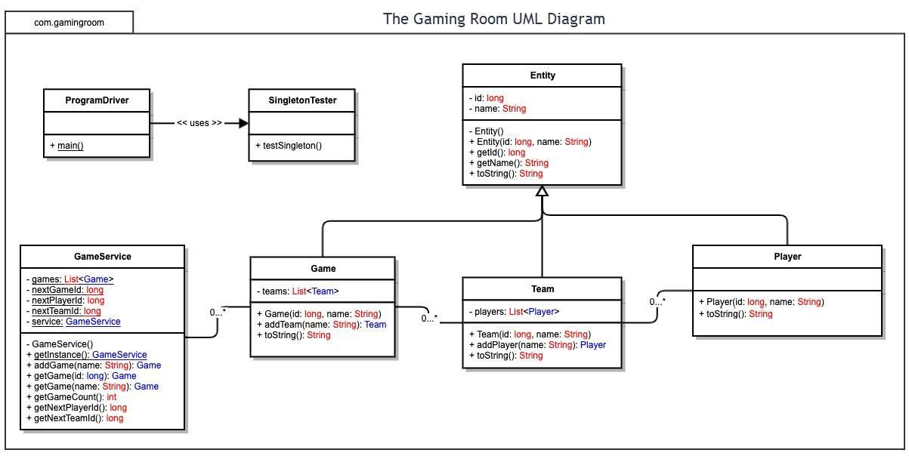

Evaluation

The following evaluation compares hosting, browser support, and development needs for expanding Draw It or Lose It beyond Android. A shared web interface allows Mac, Linux, Windows, Android, and iOS players to use the same game service. Costs below distinguish software licensing from hardware, hosting, support, and staff time; no measured capacity or fixed project budget is assumed.

The proposed implementation retains Java for the backend and uses responsive HTML, CSS, and JavaScript for clients. Numbered citations identify supporting vendor documentation in the Evaluation Sources section.

Development Requirements | Mac | Linux | Windows | Mobile Devices
Server Side | Java web services can be run on macOS using Apache or Nginx. The Unix foundation of macOS and its developer tools can help with prototyping. However, for large deployments, additional Apple hardware or macOS hosting capacity is required. Apple only allows macOS to run on Apple hardware [1]. Compared to other offerings, this provides less deployment flexibility and can be more expensive. For large deployments, high volume usage, or for high availability, this option may not be optimal as it requires load balancing, and operational and system administration expertise, moreso than Linux would. | Linux has a wider variety of deployments and supports Java application servers, Apache or Nginx. It can run on physical servers, virtual machines, and containers. Ubuntu Server does not require a per OS license, charges for commercial support, if needed, are optional [2]. This helps with cost effectiveness for additional application instances. Consider the costs for other resources like compute, storage, and network. The administration of the resources adds cost as well. Administrators need prior Linux deployment and security skills. For hosting thousands of players, CTS can add load balancing, shared game state, monitoring, and measured capacity planning.  . | Windows Server can run Java with Internet Information Services(IIS) serving web content or configured reverse proxy. It is cost effective for teams with Microsoft administration experience, and supports scale out deployments and virtual machines. CTS would have to request a custom quote for hosting [3]. Overall, it's a good option, but additional consideration for licensing and administration adds to the cost without adding any benefits. | Android devices can run some experimental server software, but neither Android nor iOS devices can run a practical production server for thousands of players. Availability is compromised due to battery limits, device sleep, changing networks, and restrictions on background work. Android limits background work and services [4]. There are no affordable mobile server license options to cover this design approach. Buyable phones are not server infrastructure. A separately hosted back end for game state is needed for both mobile platforms.
Client Side | Mac players should use the shared HTML, CSS, and JavaScript interface in Safari, Chrome, or Firefox. This will mean they don't have to use a separate macOS application and save development time. CTS still needs Mac test hardware and staff that can do responsive layouts and accessibility as well as debug browsers. Image reveals and resizing, as well as reconnection of test hardware, should be done using the real version of Safari. Automated browsers should be used for testing keyboard input. Browser differences means there is regression testing, so having a shared codebase reduces cost, but eliminating quality assurance is not possible. | Most distributions of Linux have a responsive web interface which can be used by players. This web interface works with supported versions of Firefox and Chromium based browsers. No paid desktop OS license or Linux client is needed for this approach. Maintenance time and the test matrix is increased due to various fonts, display scaling, and different packages of a browser across various distributions. The team needs experience with web standards and cross browser testing. Dependencies on local Java installs or platform specific browser plug-ins should be avoided. | Other members of the team can use Edge, Chrome or Firefox to access the shared browser client. CTS would have to allocate resources for Windows test machines, and budget for browser regression work. The developers on the team will have to learn and use responsive CSS, and be aware of accessibility issues and browser debugging. Check the behavior of the player interface for animation and reconnection, and debug browser issues across supported platforms. The player device license is not related to the server license; so CTS would not incur an additional cost for developing and testing Windows native applications. | Android and iOS should have the same responsive HTML interface, touch adapted, and with automatic rotation for different orientations. Using the same code base for the mobile interfaces reduces the need for multiple native client teams. This allows the time and cost savings of using real devices for mobile testing. Test with real browsers on slow and fast networks, and with limited memory. Simulate game servers to control the deadline and reduce round time after reconnection. Browsers and web technologies avoid app store fees. Serving game content via browsers removes the need for app store releases and fees [8].
Development Tools | Build upon the existing Java service using Eclipse Temurin, Maven, and Git, and along with HTML, CSS, and JavaScript, in VS Code, for the web client. Temurin and VS Code are quality cost free options [5, 7]. Mac hardware is more expensive and adds cost; Safari Web Inspector and browser tests can help diagnose Mac issues. CTS’s Java/Web team can share source builds with other platforms. Mac hardware and software add cost; Swift and Xcode are only needed if CTS later chooses to develop a native Apple client. | Java can be built and developed using the Eclipse IDE or VS Code with the Temurin JRE using Maven, Git, HTML, CSS, and JavaScript. Playwright can be used for automation and testing [6]. Linux build automation, Shell scripts and server logs can be used for deployment and administration. The shared team requires experience with Linux administration and automation testing. This can be filled by an operations specialist. | Eclipse Temurin, Maven, Git and VS Code or Eclipse can all be used with no changes to the Java, HTML, CSS and Javascript development stack. IDEs are free for this stack [5, 7]. Playwright and Edge developer tools allow browser testing. CTS will have to budget for other testing if members of the team will be writing tests to account for differences in the production server and configuration. Windows Server expertise will only be needed if CTS chooses that hosting option. | The mobile web client uses HTML, CSS, and JavaScript and relies on browser debugging tools. Like desktop clients, it uses the same source repository. While Playwright device emulation is useful in testing web client front end, it cannot replace Android and iOS testing. One web team with the ability to perform mobile testing and usability could deliver this. If native apps are required later, android studio with Java and Xcode with Swift add specialist work, separate releases, and hardware costs. Apple store distribution also imposes membership requirements [8].

Evaluation Implications
Across all four platform categories, the client OS does not impact the server OS. Browsers must use HTTPS for requests and secure WebSockets for live game events. The server must validate guesses and implement unique names and identifiers. The server must manage the 1-minute round deadlines, 30-second drawing reveal and 15-second windows for remaining team members to guess. Clients should be able to display timing provided by the server and resume the game from the server’s last known state. This helps accommodate slower devices.

Supporting thousands of players would require more than choosing a server OS. The Java Singleton limits a game service to one game per Java process. Currently, there is no mechanism to limit a game service to one game per server. Before scaling out CTS, they should ensure unique identifiers are managed in a synchronized data storage, as opposed to the server process, and game events are synchronized across processes. Load tests should measure the game’s tolerance for simulating thousands of concurrent connections. The image delivery bandwidth should be measured as well. With a shared Java/Web team supported by testing and operations, all the browsers clients can be built. A shared team is more effective than four distinct platform teams.

Evaluation Sources
[1] Apple. (2024). Software license agreement for macOS Sequoia. https://www.apple.com/legal/sla/docs/macOSSequoia.pdf
[2] Canonical. (2026). Ubuntu Server. https://ubuntu.com/server
[3] Microsoft. (2025). Windows Server 2025 licensing guide. https://www.microsoft.com/licensing/docs/documents/download/Licensing_guide_PLT_Windows_Server_2025.pdf
[4] Google. (2026). Background execution limits. Android Developers. https://developer.android.com/about/versions/oreo/background
[5] Microsoft. (n.d.). License for Visual Studio Code. https://code.visualstudio.com/license
[6] Microsoft. (2026). Browsers. Playwright. https://playwright.dev/docs/browsers
[7] Eclipse Adoptium. (n.d.). Eclipse Temurin. https://adoptium.net/
[8] Apple. (n.d.). Developer account overview. https://developer.apple.com/help/account/basics/about-your-developer-account

Recommendations

Analyze the characteristics of and techniques specific to various systems architectures and make a recommendation to The Gaming Room. Specifically, address the following:

Operating Platform: Draw It or Lose It requires a good server and Java framework and a stable development environment. I recommend using a Linux server platform in a cloud computing environment. Ubuntu Server LTS is an excellent option. Linux offers a lot of benefits for cost, stability, and scalability, which makes it a great choice for a server side Java platform like Dropwizard. Linux requires good networking, process management, and security to support many users.
One benefit of deploying a Linux based application is support for containers. Coupled with Linuxt's flexibility and modular nature, allows for an application to deployed to multiple servers if needed. Because Linux supports all users through standard HTTPS/REST, it supports Windows, Mac, iOS, Android and all future Console clients without a problem.

Operating Systems Architectures: Linux is a modular kernel architecture. The kernel handles almost everything leaving modules flexible. The kernel is loaded in user space, meaning applications are loaded in kernel space. The Draw It or Lose It application, along with the Java runtime, webserver, database client, and monitoring tools are loaded in user space. User space applications do not access memory/hardware directly, which improves the stability of the OS. Mistakes in applications do not affect the OS.
Similarly to Windows, Linux is a multi-capable platform that can support multiple users. It supports several database connections, concurrent image processing, backups and logging. The Linux scheduler determines how the CPU is shared among all the processes. For the Gaming Room, it means the Linux based gaming operating system can run multiple game sessions at the same time.
Storage Management: The recommended storage design separates structured data from large image assets. PostgreSQL can store game data including user and player profiles, game session data, game scores, game puzzle data, game session audits, and other game data. PostgreSQL supports constraints, transactions and role-based access control. These features assist in maintaining data accuracy. The image files should not be stored in PostgreSQ (PostgreSQL Global Development Group, n.d.).
The original image library takes up about 1.6 GB. The system will have to allocate space for optimized images, database backups, logs, and other image files. Object storage is best suitable to store the images because it is efficient to store large static data. The image files can be stored in object storage. Other data including the image file identifier, location, answer, category, metadata, and other game data can be stored in PostgreSQL.
An ext4 or XFS file system is appropriate for application files, logs, and temporary files on the Linux server. Monitor storage capacity. Automated backups should be stored separately from production data and versioning for image files should be used to prevent overwriting a valid image. Lifecycle rules can be set to reduce the storage cost for game assets, logs, and older backups, while keeping game assets immediately available.

Memory Management: Linux servers use virtual memory, paging, and process isolation to manage memory. Each process is given its own memory space. When a memory page is swapped out to hard disk it can take a relatively long time to load. While swapping delays the failure of a process to run, it's much slower than RAM and should not be used to store images that are loaded and used by the process.
The Draw It or Lose It server shouldn't load all 200 high definition images into memory. The server should load and process the image required for the current game round. The Draw It or Lose It server can store images and a few rounds after in a bounded in memory cache. When the cache is full, the least recently used image should be removed. This improves the Draw It or Lose It game server's performance to load and display images.
One way to deal with memory consumption is through garbage collection. It is important to track memory consumption, garbage collection pauses, and response time during load testing. Container memory limits can prevent one application instance from consuming the entire memory in a server. This technique is important because many games can be hosted at a time.

Distributed Systems and Networks: Draw It or Lose It should use a distributed client-server model. The clients connect to the Draw It or Lose It Server via an HTTPS connection. The Draw It or Lose It server is responsible for account management, game creation, and team management using RESTful endpoints. The Draw It or Lose It Server should push updates to clients via WebSockets. WebSockets are best suited for data that frequently changes, like the status of a round, a timer, player guesses, and player scores.
A distributed system is composed of many services and dependencies. A few of the services and dependencies are client devices, DNS, the Internet, a load balancer, application servers, a database, object storage and an authentication service. Faults in the dependencies should be considered as well. For example, a client may lose Internet connectivity, a server may go down, and a request to storage may time out. Clients should gracefully fail, time out and/or handle errors to some degree. This can be done by providing a user-friendly error to the client. Servers should be monitored with logging, and health checks. Backups of the servers database should be performed as well. It is recommended to run multiple server instances behind a load balancer to provide fault tolerance and maximize concurrency.

Security: We want to ensure the protection of user data on the Linux server, and while it is being transmitted to other services. For now we have used Basic HTTP and HTTPS and Basic Authentication, but for production we suggest the use of TLS, along with hashed and salted passwords, and secure session tokens, perhaps along with an OAuth IDP.
RBAC should be configured to allow normal users to perform only normal functions and admin users to perform only admin functions. Linux file permissions should be set in a way that only app service accounts can read the app configurations, logs, and database and app backups. The app service should be run under a non-privileged account, and administrators should ensure that the accounts have least privilege.
Only required ports, for example HTTPS port, should be open and others should be blocked. The Gaming Room should ensure that the operating systems and dependencies are up to date, perform centralized logging, validate client inputs, and limit the expiration of session tokens. Suspicious login attempts should be blocked. The OWASP Foundation recommends protecting sensitive info using TLS, and not logging sensitive info and credentials (OWASP Foundation, n.d.) and the app should implement the same for the user apps it serves.
References
OWASP Foundation. (2026). Transport layer security cheat sheet. https://cheatsheetseries.owasp.org/cheatsheets/Transport_Layer_Security_Cheat_Sheet.html

PostgreSQL Global Development Group. (n.d.). PostgreSQL documentation. https://www.postgresql.org/docs/

Ubuntu. (2026). Ubuntu Server documentation. https://documentation.ubuntu.com/server/

